Paper Title (Times New Roman, 23, Normal, Bold)
Name of Author¹, Name of Author², Name of Author³, Name of Author⁴ (12, Times,Bold)
¹UG-PG student, Research Scholar, Asstt / Asso. Professor, Professor, Dr. (10,Times ,Italic)
Name of the Institute, City, Country, Pin, email ID of Correspondence author
²UG-PG student, Research Scholar, Asstt / Asso. Professor, Professor , Dr.
Name of the Institute, City, Country, Pin, email ID of Co-authors
(You can add max. 04 authors)

Abstract –Paper size is A4, Margins 0.7’’ from all four sides .Abstract should be in form of times new roman size 10 italic form.Abstract should be in form of times new roman size 10 italic form.Abstract should be in form of times new roman size 10 italic form.Abstract should be in form of times new roman size 10 italic form.Abstract should be in form of times new roman size 10 italic form.Abstract should be in form of times new roman size 10 italic form.Abstract should be in form of times new roman size 10 italic form.Abstract should be in form of times new roman size 10 italic form.Abstract should be in form of times new roman size 10 italic form.Abstract should be in form of times new roman size 10 italic form.Abstract should be in form of times new roman size 10 italic form.Abstract should be in form of times new roman size 10 italic form.(150- 200 words)
Keywords- Keyword should be times new roman size 10 italic, bold. (max. 06 keywords)
- INTRODUCTION
Introduction should be in times new roman size 10 normal, line spacing 1.15 inches, justified.Introduction should be in times new roman size 10 normal,line spacing 1.15 inches justified. Introduction should be in times new roman size 10 normal, justified.Introduction should be in times new roman size 10 normal,line spacing 1.15 inches justified. Introduction should be in times new roman size 10 normal, justified.Introduction should be in times new roman size 10 normal,line spacing 1.15 inches justified.

II. LITERATURE REVIEW
Add Literature review of the earlier papers in your work area here. Citations should be mentioned clearly.
Should be in times new roman size 10 normal,line spacing 1.15 inches justified. should be in times new roman size 10 normal, justified.should be in times new roman size 10 normal,line spacing 1.15 inches justified.
III. METHODOLOGY
(Includes System block diagram, circuit diagram & description, Hardware details, System flow diagram, Algorithm description, Pseudo code in brief if any.)
All matter of the paper here after should be times new roman size 10 normal size, line spacing 1.15 inches, justified.
Table 1- Title of table (10, Normal)
Sr.No | Item 1 | Item 2 | Item 3 | Item4
1 | Abcd | Abcd | Abcd | abcd
2 | Abcd | Abcd | Abcd | abcd
3 | Abcd | Abcd | Abcd | abcd
4 | Abcd | Abcd | Abcd | abcd

The line spacing for the table content should be single only.
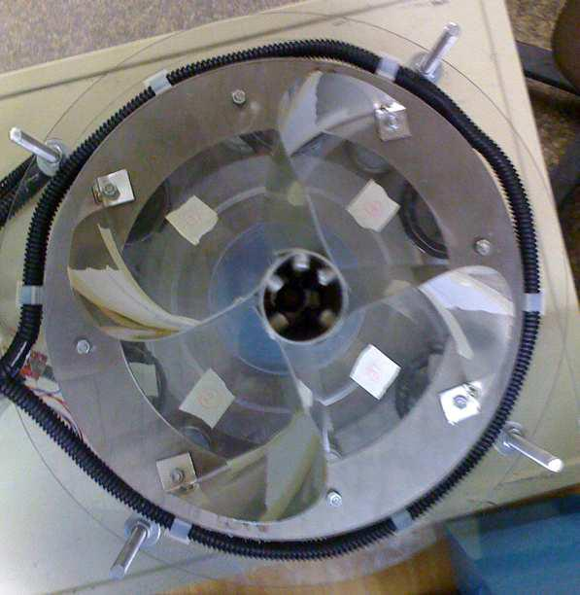

Fig. 1- fig shows the matter (10, Normal)
The contents of the paper should be size 10 normal, line spacing 1.15, justified.The contents of the paper should be size 10 normal, line spacing 1.15, justified.
The contents of the paper should be size 10 normal, line spacing 1.15, justified.The contents of the paper should be size 10 normal, line spacing 1.15, justified. The contents of the paper should be size 10 normal, line spacing 1.15, justified.The contents of the paper should be size 10 normal, line spacing 1.15, justified.
IV. DESIGN (if any)
All the equations should be typed using equation editor, equations should not split.
$$\left[\begin{matrix}ω_{1} \\ ω_{2} \\ ω_{3} \\ ω_{4}\end{matrix}\right]=\frac{1}{R}\left[\begin{matrix}1 & 1 & -(l_{1}+l_{2}) \\ 1 & -1 & l_{1}+l_{2} \\ 1 & -1 & -(l_{1}+l_{2}) \\ 1 & 1 & l_{1}+l_{2}\end{matrix}\right]*\left[\begin{matrix}u_{x} \\ v_{y} \\ w_{z}\end{matrix}\right]$$

V. RESULT & DISCUSSION
The contents of the paper should be size 10 normal, line spacing 1.15, justified.The contents of the paper should be size 10 normal, line spacing 1.15, justified. The contents of the paper should be size 10 normal, line spacing 1.15, justified.The contents of the paper should be size 10 normal, line spacing 1.15, justified.The contents of the paper should be size 10 normal, line spacing 1.15, justified.The contents of the paper should be size 10 normal, line spacing 1.15, justified. The contents of the paper should be size 10 normal, line spacing 1.15, justified.The contents of the paper should be size 10 normal, line spacing 1.15, justified.The contents of the paper should be size 10 normal, line spacing 1.15, justified.
VI. CONCLUSION
The contents of the paper should be size 10 normal, line spacing 1.15, justified. The contents of the paper should be size 10 normal, line spacing 1.15, justified.The contents of the paper should be size 10 normal, line spacing 1.15, justified.The contents of the paper should be size 10 normal, line spacing 1.15, justified.The contents of the paper should be size 10 normal, line spacing 1.15, justified. The contents of the paper should be size 10 normal, line spacing 1.15, justified.The contents of the paper should be size 10 normal, line spacing 1.15, justified.The contents of the paper should be size 10 normal, line spacing 1.15, justified.
ACKNOWLEDGMENT (if any)
Acknowledgment to person or the organization supported to the author for the research work. This is not mandatory for all.
REFERENCES
- Ilon, B. E. (1975). Wheels for a Course Stable Selfpropelling Vehicle Movable in any Desired Direction on the Ground or Some Other Base. U.S. Patent. U.S.A.
- Everett, H.R. (1995). Sensors for Mobile Robots: Theory and Application. A K Peters, Ltd, MA, USA.
- Diegel, O.; Badve, A.; Bright, G.; Potgieter, J. &Tlatle, S. (2002). Improved Mecanum Wheel Design for Omni-directional Robots, Proc. 2002 Australian Conference on Robotics and Automation, Auckland, 27-29 Nov. 2002, pp. 117-121.
- Borenstein, J.; Everett, H.R. &Feng, L. (1996). Navigating Mobile Robots: Sensors and Omni directional Mobile Robot – Design and Implementation IoanDoroftei, Victor Grosu and VeaceslavSpinu “Gh. Asachi” Technical University of Iasi Romania Techniques. A K Peters, Ltd, MA, USA.
- IoanDoroftei; Victor Grosu and VeaceslavSpinu; “Omnidirectional mobile robot- Design and Implimentation” from “Gh.Asachi” Technical university of lasi, Romania.
- Olaf Diegel, AparnaBadave, Glen Bright, Johan Potgieter, Sylvester Tlale, (2002) “Improved Mecanum Wheel Design for Omni-directional Robot”, Australasian Conference on Robotics And Automation, Auckland.
- Ilon, B. E. (1975). Wheels for a Course Stable Selfpropelling Vehicle Movable in any Desired Direction on the Ground or Some Other Base. U.S. Patent. U.S.A.
- Everett, H.R. (1995). Sensors for Mobile Robots: Theory and Application. A K Peters, Ltd, MA, USA.
- Diegel, O.; Badve, A.; Bright, G.; Potgieter, J. &Tlatle, S. (2002). Improved Mecanum Wheel Design for Omni-directional Robots, Proc. 2002 Australian Conference on Robotics and Automation, Auckland, 27-29 Nov. 2002, pp. 117-121.
- Borenstein, J.; Everett, H.R. &Feng, L. (1996). Navigating Mobile Robots: Sensors and Omni directional Mobile Robot – Design and Implementation IoanDoroftei, Victor Grosu and VeaceslavSpinu “Gh. Asachi” Technical University of Iasi Romania Techniques. A K Peters, Ltd, MA, USA.
- IoanDoroftei; Victor Grosu and VeaceslavSpinu; “Omnidirectional mobile robot- Design and Implimentation” from “Gh.Asachi” Technical university of lasi, Romania.

References shall be in above format. All format are given i.e. reference taken either from journal paper, books, research article, patents, thesis etc.. Use which is applicable as per references you have with you.

(Max. 06 pages are allowed. Additional page will be charged as Rs. 200/- per page.)

